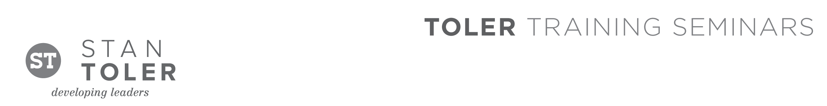
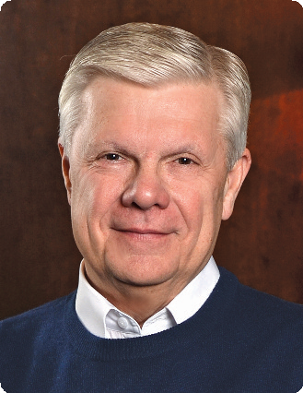

TEACHING TO INFLUENCE LIVES

A Content-Packed Seminar That Will Enhance Your Teaching Skills!
featuring Stan Toler

One of the greatest challenges to teachers is finding a way to allow God to move freely so that students can experience His leading.

Whether you’re a pastor, Sunday school teacher, Christian educator, small group leader, or home schooler, the objective is the same: You want to achieve excellence in communicating God’s truth!

TEACHING TO INFLUENCE LIVES will help you achieve your goal. Whether you’ve been teaching for twenty years or have just assumed the responsibility for teaching your first Sunday school class, you will benefit from this dynamic one-day event. Teaching to Influence Lives is a highly inspirational seminar that is rich in content and certain to contain a wealth of material relevant to every teaching situation. Led by Stan Toler, one of America’s foremost Christian educators, this seminar will give you more in one day than you would get from a shelf full of books.

Teach God’s Word powerfully, practically, and profoundly.

You Will Learn:
• How to become a better teacher.
• The key to effective preparation.
• How to motivate your audience every time you teach.
• How to make every teaching situation exciting.
• How to use new technology.

Stan Toler is a dynamic international speaker, having spoken in over 90 countries of the world. He has written over 100 books, including his best-sellers, The Power of Your Attitude, Outstanding Leadership, The Secret Blend, The Relational Leader, his popular Minute Motivator series, Total Quality Life and TERRIFIC! Five Star Customer Service. His books have sold over 3 million copies.

Toler for many years served as Vice-President and taught seminars for John C. Maxwell’s INJOY Leadership Institute training church and corporate leaders to make a difference in the world.

[Insert your organization’s information here]

