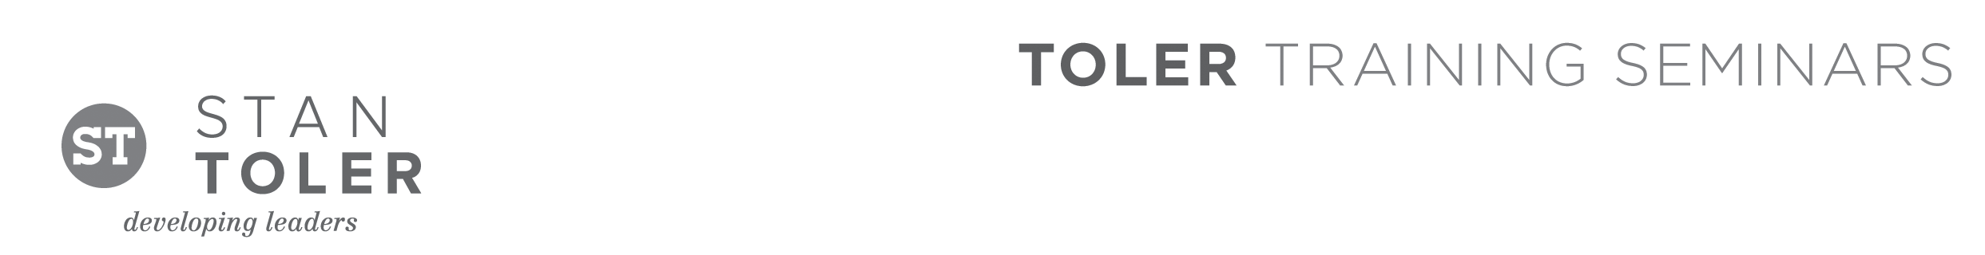
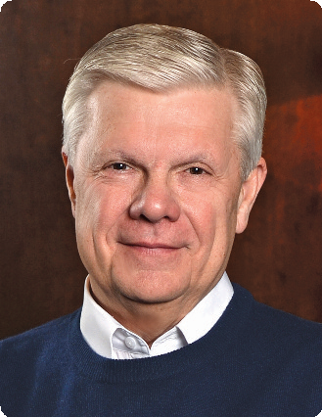

The Power of Your Attitude

A Content-Packed Seminar for Every Leader!
featuring Stan Toler

Whether you are a young person just getting established, in the middle of life, or enjoying retirement, you will grow under the inspired teaching of Dr. Stan Toler at this dynamic event. This is a seminar that you will not want to miss as you learn how to transform your attitude for a happy and successful life.

You Will Learn:
• How to develop a healthy outlook on life.
• Which daily disciplines impact your daily decisions.
• How to move toward an extreme life makeover.
• How to attain a new level of achievement.
• The five stars of a Total Quality Life.

Stan Toler is a dynamic international speaker, having spoken in over 90 countries of the world. He has written over 100 books, including his best-sellers, The Power of Your Attitude, Outstanding Leadership, The Secret Blend, The Relational Leader, his popular Minute Motivator series, Total Quality Life and TERRIFIC! Five Star Customer Service. His books have sold over 3 million copies.

Toler for many years served as Vice-President and taught seminars for John C. Maxwell’s INJOY Leadership Institute training church and corporate leaders to make a difference in the world.

[Insert your organization’s information here]

