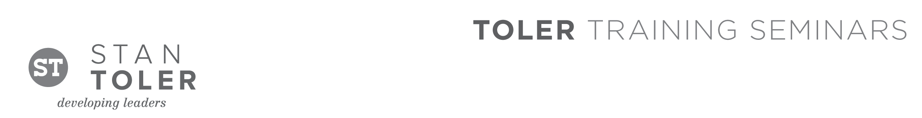
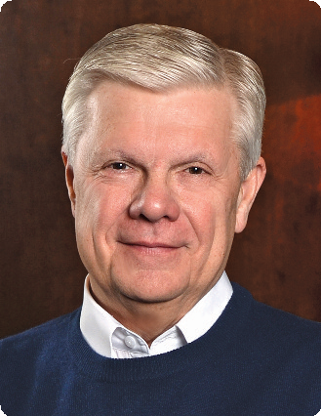

GIVE TO LIVE

A Content-Packed Seminar for Every Leader!
featuring Stan Toler

GIVE TO LIVE is a one-day event that will show you—step-by-step—how to turn self-focused consumers into faithful stewards. Members of your church or organization will learn practical methods for creating a Bible-based giving environment. Author and international seminar leader, Dr. Stan Toler, will share from his years of experience in church finance, organizational management, as well as building programs in all church size strategies.
Bring as many as possible. Share the exciting vision for giving and receiving according to the promises of God’s Word—in a positive and upbeat learning atmosphere.

You Will Learn:
WHO should attend:
• Pastors and church staff.
• Church treasurers.
• Church board members.
• Finance ministry team members.
• Leaders of Christian organizations.
• Interested laypersons.

WHAT you will learn:
• Exciting ways to increase your weekly offerings.
• Strategies to build a workable budget.
• Creative ways to finance your ministry.
• Planned giving & estate planning information.
• Ways to teach people how to be financially free.
• Current trends in paying the pastoral staff.

HOW you will benefit:
• Learn to think globally as well as locally.
• Learn to develop stewardship leaders.
• Learn to develop your leadership base.
• Learn how to create positive stewardship
attitudes.

Stan Toler is a dynamic international speaker, having spoken in over 90 countries of the world. He has written over 100 books, including his best-sellers, The Power of Your Attitude, Outstanding Leadership, The Secret Blend, The Relational Leader, his popular Minute Motivator series, and Give to Live: The Freedom of Being Generous With Your Life. His books have sold over 3 million copies.

Toler for many years served as Vice-President and taught seminars for John C. Maxwell’s INJOY Leadership Institute training church and corporate leaders to make a difference in the world.

[Insert your organization’s information here]

