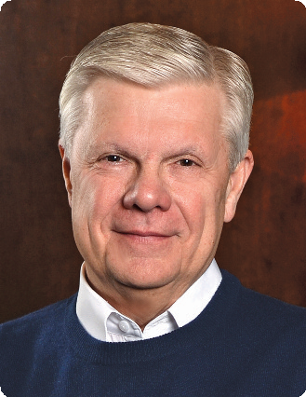

THE FIVE-STAR CHURCH

A Content-Packed Seminar for Every Leader!
featuring Stan Toler

Taught by Christian leader, Dr. Stan Toler, The Five-Star Church seminar will cause every pastor, ministry team leader, and church worker to re-evaluate their commitment to ministry and strive for a new level of excellence.
Based on the best-selling book, THE FIVE-STAR CHURCH (now in its 25th printing), you will
discover innovative ideas for transforming your church into a ministry of excellence. You will also
understand how to evaluate the progress and performance of your various ministries. It will challenge your church leaders to servant-hood and ministry effectiveness.

You Will Learn:
• How to build a quality ministry that not only honors God, but also makes everyone in
your church feel welcome and cared for.
You Will Be Given:
• The necessary tools to evaluate the performance of your ministries, and to
establish a rating for the services you provide.
You Will Discover:
• The importance of having the right people, at the right time, and in the right place
to ensure quality ministry.

Stan Toler is a dynamic international speaker, having spoken in over 90 countries of the world. He has written over 100 books, including his best-sellers, The Power of Your Attitude, Outstanding Leadership, The Secret Blend, The Relational Leader, his popular Minute Motivator series, Total Quality Life and TERRIFIC! Five Star Customer Service. His books have sold over 3 million copies.

Toler for many years served as Vice-President and taught seminars for John C. Maxwell’s INJOY Leadership Institute training church and corporate leaders to make a difference in the world.

[Insert your organization’s information here]

