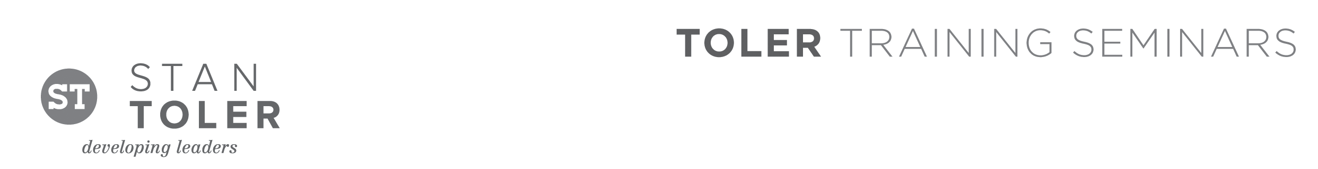
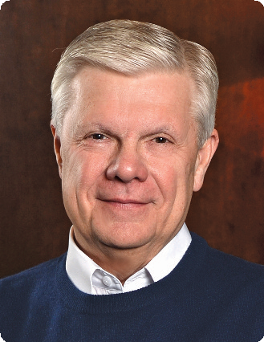

THE EXCEPTIONAL LEADER

A Content-Packed Seminar for Every Leader!
featuring Stan Toler

This one-day event will give you the tools to move to the next level of leadership. Best-selling author and international seminar leader, Dr. Stan Toler, will lead you in an action-packed seminar that will give you a vision for personnel and corporate excellence. Plus, you will be led step-by-step in setting goals, identifying time wasters, increasing influence, and delegating projects. You will also learn how to mentor others in reaching their own goals.

THE EXCEPTIONAL LEADER is a seminar that you will not want to miss, and we promise you will
go home with real handles that you can use in your personal development and in leading your
organization. Stan Toler is also author of Minute Motivator for Leaders, one in the popular Minute
Motivator series, which has been distributed internationally.

You Will:
• Discover how to become a follower as well as a leader.
• Learn the five keys to exceptional leadership.
• Gain insights on managing your time and maximizing your abilities.
• Get motivated to build and inspire your team.
• Learn how to build winning relationships.
• Be challenged to become a transformational leader.
• Hear life changing stories about leaders who make a difference.

Stan Toler is a dynamic international speaker, having spoken in over 90 countries of the world. He has written over 100 books, including his best-sellers, The Power of Your Attitude, Outstanding Leadership, The Secret Blend, The Relational Leader, his popular Minute Motivator series, Total Quality Life and TERRIFIC! Five Star Customer Service. His books have sold over 3 million copies.

Toler for many years served as Vice-President and taught seminars for John C. Maxwell’s INJOY Leadership Institute training church and corporate leaders to make a difference in the world.

[Insert your organization’s information here]

