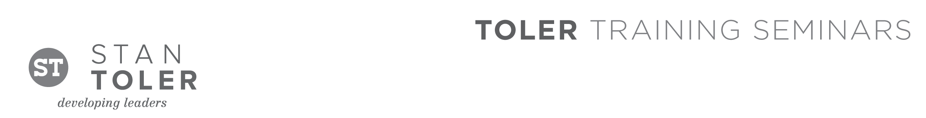
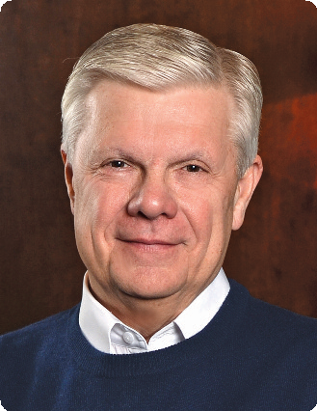

THE RELATIONAL LEADER

A Content-Packed Seminar for Every Leader!
featuring Stan Toler

The organizational, emotional, relational, and financial demands of ministry are greater than ever before. This one-day seminar taught by Dr. Stan Toler will both encourage you and reinforce what you are already doing. Plus, you will receive real handles that you can use to sharpen your ministry focus and challenge your church to grow.

You Will Learn:
Relational LEADERSHIP
• Character Development
• Effective Leadership
• Insightful Coaching

Relationship BUILDING
• Nine Laws of Relationships
• Winsome Attitude
• Growing as a Team

Collaborative TEAMWORK
• Visioning
• Reforming
• Growing

Effective COMMUNICATION
• Operational Excellence
• Meaningful Meetings
• Conflict Management

Who should attend? Senior pastors, associates, lay leaders, and anyone in your church or organization who could benefit from learning the keys to effective, relational leadership!

Stan Toler is a dynamic international speaker, having spoken in over 90 countries of the world. He has written over 100 books, including his best-sellers, The Secret Blend, The Relational Leader, The Exceptional Leader, ReThink Your Life, his popular Minute Motivator series, Total Quality Life, TERRIFIC! Five Star Customer Service, and his latest release, Outstanding Leadership. His books have sold over 3 million copies.

Toler for many years served as Vice-President and taught seminars for John C. Maxwell’s INJOY Leadership Institute training church and corporate leaders to make a difference in the world.

[Insert your organization’s information here]

