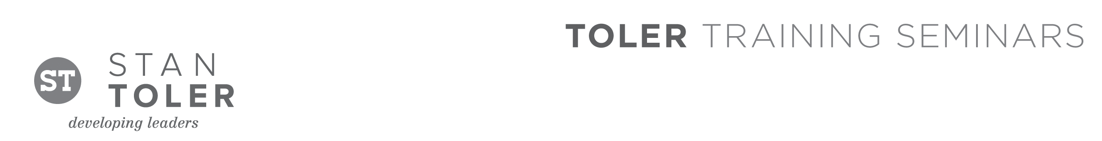
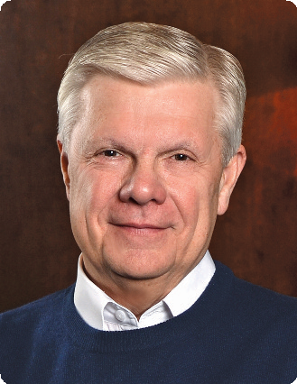

TERRIFIC!
Five-Star Customer Service

A Content-Packed Seminar for Every Leader!
featuring Stan Toler

Best-selling author and international seminar leader Stan Toler presents a hands-on, dynamic seminar that will teach you how to reach and keep customers with time-tested principles of Terrific! customer service. Using examples from the lives of people with Down Syndrome who have excelled in impacting the lives of thousands, you will learn the basics of connecting with your customers in a warm, personal, and attentive way.

TERRIFIC! FIVE-STAR CUSTOMER SERVICE is a one-day event filled with highly practical content.
From discovering the birth of creativity, to building enthusiasm, to incorporating a personal touch, each
component of the seminar will be taught in a relaxed and positive environment. John C. Maxwell calls Stan
“Mr. Relationship” for his engaging style and down-to-earth teaching.

You Will Learn:
• How to develop a winning attitude.
• How to offer creative customer service.
• How to use centricity in reaching customers at a personal level.
• How to improve the telling of your story.
• How to find out what the customer really wants.
• How to confirm the customer.

Stan Toler is a dynamic international speaker, having spoken in over 90 countries of the world. He has written over 100 books, including his best-sellers, The Power of Your Attitude, Outstanding Leadership, The Secret Blend, The Relational Leader, his popular Minute Motivator series, Total Quality Life and TERRIFIC! Five Star Customer Service. His books have sold over 3 million copies.

Toler for many years served as Vice-President and taught seminars for John C. Maxwell’s INJOY Leadership
Institute training church and corporate leaders to make a difference in the world.

[Insert your organization’s information here]

