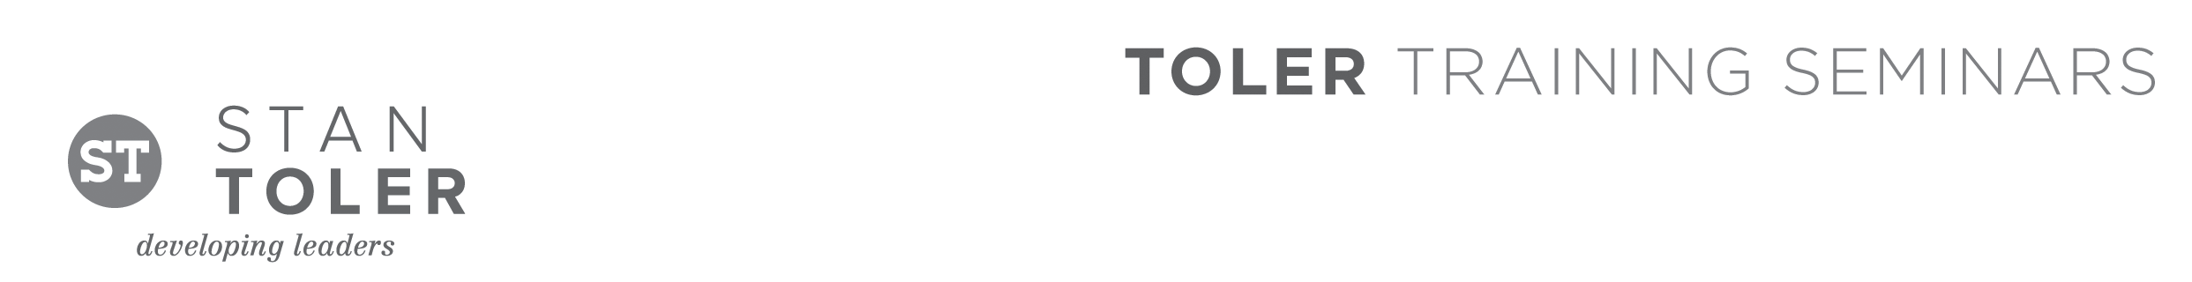
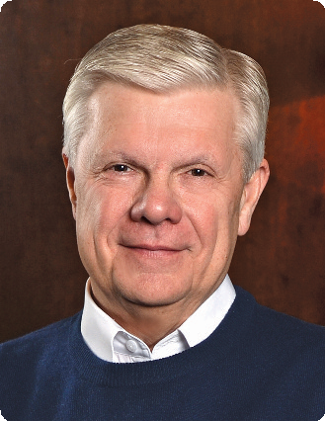

TOTAL QUALITY LIFE

A Content-Packed Seminar for Every Leader!
featuring Stan Toler

Whether you are a young person just getting established, in the middle of life, or enjoying retirement, you will grow under the inspired teaching of Dr. Stan Toler at this dynamic event. This is a seminar that you will not want to miss, and we promise you will go home with real handles that you can use to simplify your life and move toward personal peace.

You Will Learn:
• Learn how to detoxify your mind and body and reintroduce
right thoughts into your life.
• Learn how to recognize your gifts that don’t involve money.
• Learn which daily disciplines impact your daily decisions.
• Learn the action steps for removing the busy clutter from your life.
• Learn to banish negative thinking and establish a transformed view
of Total Quality Life in today’s chaotic world.
• Learn how to help lift your organization to a new level of achievement.

Stan Toler is a dynamic international speaker, having spoken in over 90 countries of the world. He has written over 100 books, including his best-sellers, The Power of Your Attitude, Outstanding Leadership, The Secret Blend, The Relational Leader, his popular Minute Motivator series, Total Quality Life and TERRIFIC! Five Star Customer Service. His books have sold over 3 million copies.

Toler for many years served as Vice-President and taught seminars for John C. Maxwell’s INJOY Leadership Institute training church and corporate leaders to make a difference in the world.

[Insert your organization’s information here]

