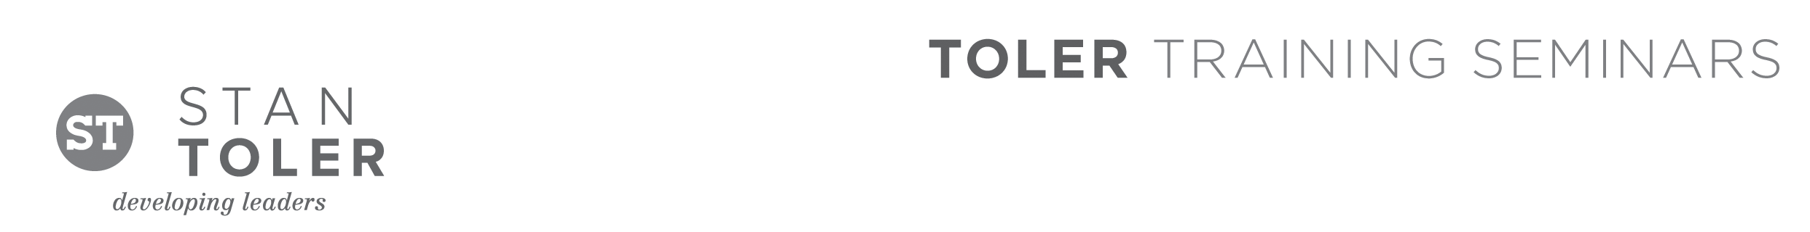
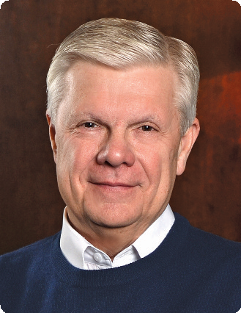

THE POWER OF ONE

A Content-Packed Seminar for Every Leader!
featuring Stan Toler

Jesus not only gave his followers a job to do, he gave them a divine resource with which to do it—the power of his Holy Spirit (Acts 1:8). THE POWER OF ONE has been used worldwide to teach believers how to tap into that resource. Thousands of leaders have been trained worldwide and hundreds
of churches have been planted as a result.

This one-day seminar will inspire and equip you to use a proven method for expanding God’s kingdom. Bring as many people from your church or organization as possible. Discover how Spirit-anointed vision and training can result in reaching entire communities with the gospel.

You Will Learn:
• How to utilize prayer in evangelizing unbelievers, discipling believers, and starting new churches.
• How to plan a local church or community outreach event.
• How to establish friendship networks to introduce people to Christ and other Christians.
• How to present the gospel message in a concise and relevant way.

Stan Toler is a dynamic international speaker, having spoken in over 90 countries of the world. He has written over 100 books, including his best-sellers, The Power of Your Attitude, Outstanding Leadership, The Secret Blend, The Relational Leader, his popular Minute Motivator series, Total Quality Life and TERRIFIC! Five Star Customer Service. His books have sold over 3 million copies.

Toler for many years served as Vice-President and taught seminars for John C. Maxwell’s INJOY Leadership Institute, training church and corporate leaders to make a difference in the world.

[Insert your organization’s information here]

