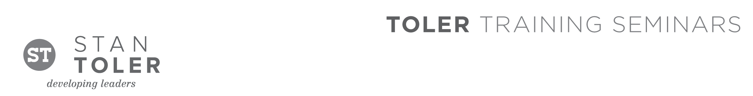
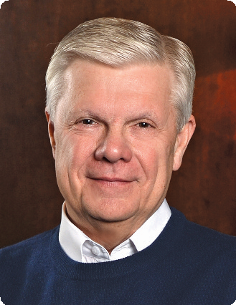

OUTSTANDING!
Leadership that Motivates and Relates

A Content-Packed Seminar for Every Leader!
featuring Stan Toler

This one-day event taught by best-selling author and international speaker Stan Toler will benefit business, non-profit and community leaders. Don’t miss this enlightening and exciting workshop.

Toler will inspire, encourage, and challenge those who want to become outstanding in their leadership role at work, church, home, or school.

You Will Learn:
• How to develop a vision plan
• Qualities of an effective vision
• Keys to becoming a great communicator
• Steps to building winning relationships
• Characteristics of great leaders/coaches
• Five skills that every leader must possess
• Nine characteristics of a transformational leader

Stan Toler is a dynamic international speaker, having spoken in over 90 countries of the world. He has written over 100 books, including his best-sellers, The Power of Your Attitude, Outstanding Leadership, The Secret Blend, The Relational Leader, his popular Minute Motivator series, Total Quality Life and TERRIFIC! Five Star Customer Service. His books have sold over 3 million copies.

Toler for many years served as Vice-President and taught seminars for John C. Maxwell’s INJOY Leadership Institute training church and corporate leaders to make a difference in the world.

[Insert your organization’s information here]

