THE VIBRANT CHURCH

A Content-Packed Seminar for Every Leader!
featuring Stan Toler

The organizational, emotional, relational, and financial demands of ministry are greater than ever before. This one-day seminar taught by Dr. Stan Toler will both encourage you and reinforce what you are already doing. Plus, you will receive real handles that you can use to sharpen your ministry focus and challenge your church to grow.

You Will Learn:
Vibrant LEADERSHIP
• Ministering in today’s culture.
• Transitioning for growth in the local church.
• Building a ministry team.
• Trending issues that affect your
ministry today and tomorrow.

Vibrant RELATIONSHIPS
• Breaking through the barriers.
• Becoming culturally relevant in community relations.
• Growing people spiritually.
• Developing a global and local perspective.

Vibrant STEWARDSHIP
• Mapping the road to stewardship success.
• Designing a strategic plan for financing
ministry in the local church.
• Discovering ways to grow your church
finances.

Vibrant SPIRITUALITY
• Incorporating spiritual factors into growing
a church.
• Building a total quality spiritual culture.
• Discipling and equipping followers of Christ.

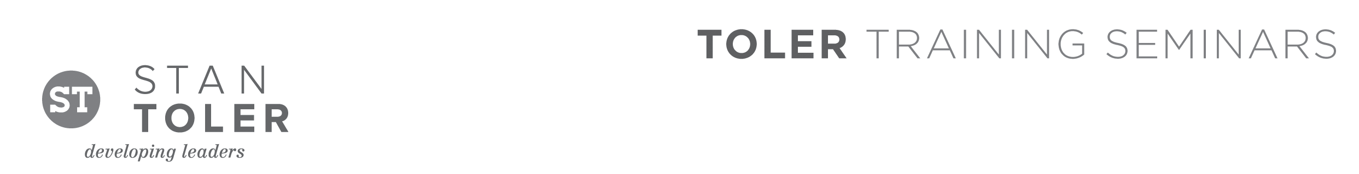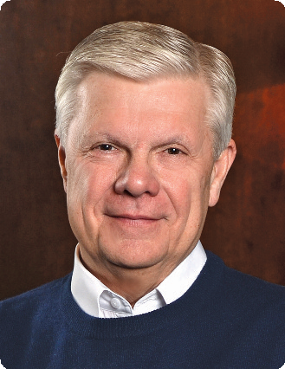

Stan Toler is a dynamic international speaker, having spoken in over 90 countries of the world. He has written over 100 books, including his best-sellers, The Secret Blend, The Relational Leader, The Exceptional Leader, ReThink Your Life, his popular Minute Motivator series, Total Quality Life and TERRIFIC! Five Star Customer Service. His books have sold over 3 million copies.

Toler for many years served as Vice-President and taught seminars for John C. Maxwell’s INJOY Leadership Institute training church and corporate leaders to make a difference in the world.

[Insert your organization’s information here]

